Digital Literacy

Submitted by: AARYESH RAHUL THORAT
Registration Number: 25MIP10076

Project Tasks

Task- 4 - Email Etiquette

Task 4 Email Etiquette & Social Media Rules

Some Emails
Requesting Assignment Deadline Extension
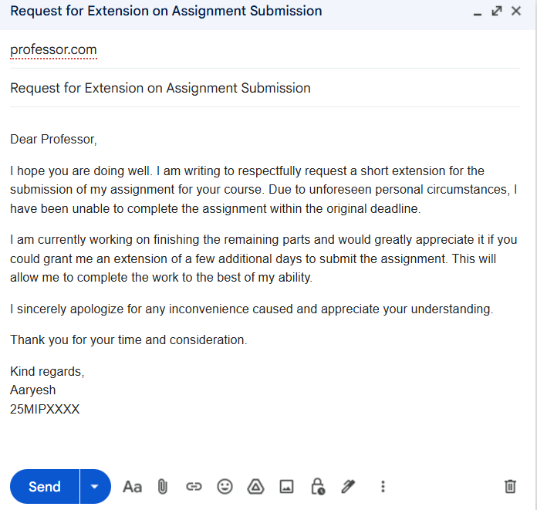

Applying for Summer Internship

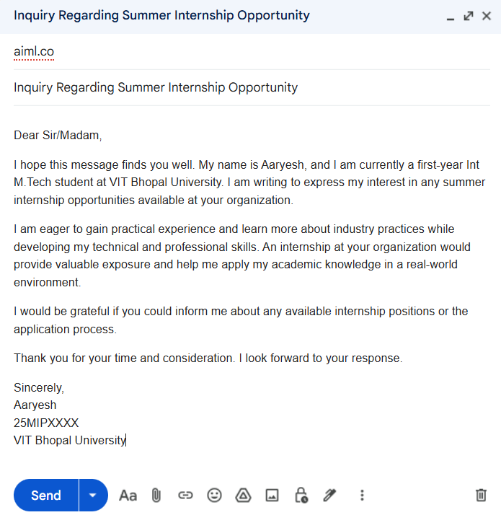

Report On Email Etiquette

Email etiquette is essential for maintaining clear, respectful, and professional communication in both academic and professional settings. Poorly written emails can lead to misunderstandings, appear unprofessional, and may even harm relationships between students, professors, or employers. For instance, if a student sends an email without a clear subject line, proper greeting, or respectful tone, the message may seem careless or impolite. In some situations, important requests might even be ignored because the email does not appear professional.
To avoid these issues, emails should always include a clear subject line, a polite greeting, a well-organized message, and a professional closing. It is also important to proofread the email before sending it to avoid mistakes. Following proper email etiquette helps create a positive impression and ensures that communication remains clear and effective.

5 Social Media Do’s
- Maintain a professional and respectful tone when posting or commenting.
- Think carefully before posting and make sure the content reflects positively on you.
- Use privacy settings to protect your personal information.
- Share educational, informative, or positive content that adds value.
- Respect others’ opinions and participate politely in online discussions.
❌ 5 Social Media Don’ts
- Do not share personal or sensitive information publicly.
- Avoid posting offensive, abusive, or inappropriate content.
- Do not spread fake news or information that has not been verified.
- Avoid cyberbullying, trolling, or making negative comments about others.
- Do not post content that could harm your personal or professional reputation.

Poor Digital Communication
Poor digital communication can easily lead to misunderstandings, conflicts, and even damage to personal or professional relationships. For example, if a student sends a message or email to a professor using very informal language, without a greeting, or with unclear sentences, it may appear disrespectful or careless. Similarly, posting negative or offensive comments on social media can create unnecessary conflicts and harm a person’s reputation.
In academic and professional environments, clear and respectful communication is very important. Messages should be written politely, with proper structure and correct language so the receiver can clearly understand the purpose of the message. Taking a few moments to review a message before sending it can help avoid mistakes and confusion. Practicing good digital communication helps build trust, maintain professionalism, and encourage positive interactions online.

